F-Test
This example teaches you how to perform an F-Test in Excel. The F-Test is used to test the null hypothesis that the variances of two populations are equal.
Below you can find the study hours of 6 female students and 5 male students.
H₀: σ₁² = σ₂²
H₁: σ₁² ≠ σ₂²
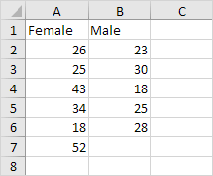
To perform an F-Test, execute the following steps.
1. On the Data tab, in the Analysis group, click Data Analysis.
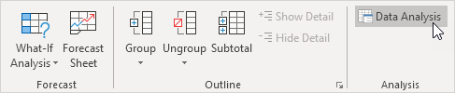
Note: can't find the Data Analysis button? Click here to load the Analysis ToolPak add-in.
2. Select F-Test Two-Sample for Variances and click OK.
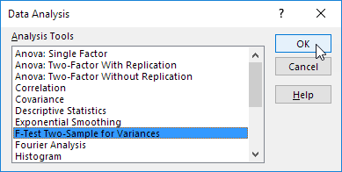
3. Click in the Variable 1 Range box and select the range A2:A7.
4. Click in the Variable 2 Range box and select the range B2:B6.
5. Click in the Output Range box and select cell E1.
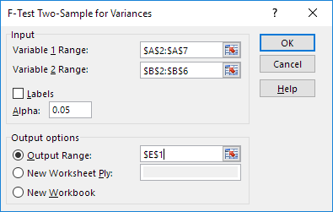
6. Click OK.
Result:
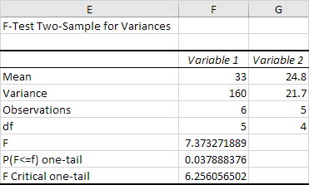
Important: be sure that the variance of Variable 1 is higher than the variance of Variable 2. This is the case, 160 > 21.7. If not, swap your data. As a result, Excel calculates the correct F value, which is the ratio of Variance 1 to Variance 2 (F = 160 / 21.7 = 7.373).
Conclusion: if F > F Critical one-tail, we reject the null hypothesis. This is the case, 7.373 > 6.256. Therefore, we reject the null hypothesis. The variances of the two populations are unequal.
Refer Table-H Page – 789 (Elementary Statistics by Bluman.pdf) for F Critical one-tail is 6.25605650216088.

